A is for Attendance!
Welcome to our attendance celebration newsletter, which will be sent out every half term to celebrate both attendance and punctuality achievements and offer hints and tips to improve it.

In school we continue to celebrate our 100% attendees on a weekly basis. This Spring Term (Jan - March) we have had 66 pupils that have achieved 100% attendance.
A HUGE WELL DONE AND CONGRATULATIONS.
These pupils have received a celebratory 100% badge and certificate along with 30 mins free time to celebrate with a hot chocolate and goodies in the staff room with Mrs Ackers and Mrs Quayle. Those who have been in 100% for half a term have also received a badge.

Don't forget, those who remain in the Green with 100% attendance for the whole school year will be entered into the prize draw to win a brand new bike or scooter. The winning class will also be treated to a party.

PUNCTUALITY - Lessons start at 9.00am - THE FIRST LESSON IS PHONICS, IF YOUR CHILD MISSES THIS THEY MISS THE KEY BUILDING BLOCKS FOR ALL LEARNING.
How much time is missed?
When staff talk about attendance percentages it can be difficult to understand why there are concerns.
Whilst 90% is a positive achievement in an examination/test, 90% attendance would warrant a significant level of concern in attendance.
Below demonstrates how much schooling is missed on a yearly basis.
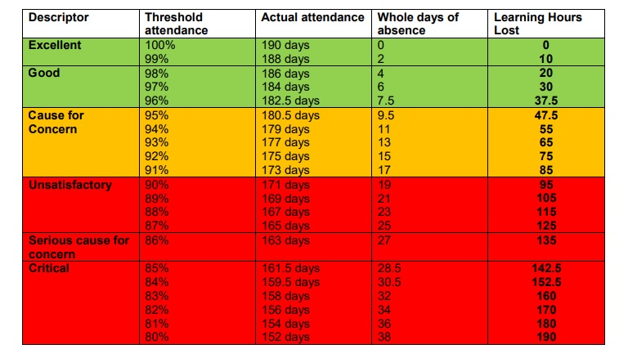
The Legal Stuff
School attendance is important because the law requires it. As parents/carers we are legally responsible for making sure our children get a full time education and can be fined by the Local Authority.

What do I do if my child is going to be absent or late?

We understand and appreciate that children can become ill and that it is not always easy to decide whether to send them into school or keep them at home. If your child is too ill to attend school, please contact the school office before 8.50am with details of your child’s illness/symptoms. If we do not hear from you, we will give you a call. You may also receive a visit from the pastoral team. This is to offer any support that may be needed.
The pastoral team have an open door policy and are always on hand to offer advice , support and guidance .

School office can be contacted on 0151 355 1650

Regular attendance is punctual attendance
EVERY SECOND COUNTS !!
Arriving on time for school is important. Late arrivals are disruptive for the whole class and can be embarrassing for the child who is late. Children can also miss important information during class registration and often miss out on early morning lessons which are vital to set them up for the day/week. Progress is also affected and children often fall behind.
Celebrations
- Attendance is celebrated every Friday via our LIVE assemblies on twitter.
- A class in each Key Stage is celebrated and a trophy awarded for the highest attendance.
- The winning classes are displayed on our attendance board in the hall for all to see.
- 100% attendance recognition stickers/ bands are awarded to ALL who have 100% that week.
- 100% attendance pupils are tweeted every Friday
- Badges are given out for those who have managed 100% attendance for HALF A TERM
- Certificates and Special Badges are given out for those who have managed 100% attendance for the TERM
- Those who have 100% attendance for the WHOLE SCHOOL YEAR are put into a draw for a bike or scooter to the amount of £120, as well as a surprise.
- Class party is awarded to the class with the highest attendance for the year.
Check us out on twitter @school_ws and @wfedwelfare
Finally a big thank you to you all for your ongoing support .
Have a fabulous well deserved break, see everyone back on time on the 20/04/22

