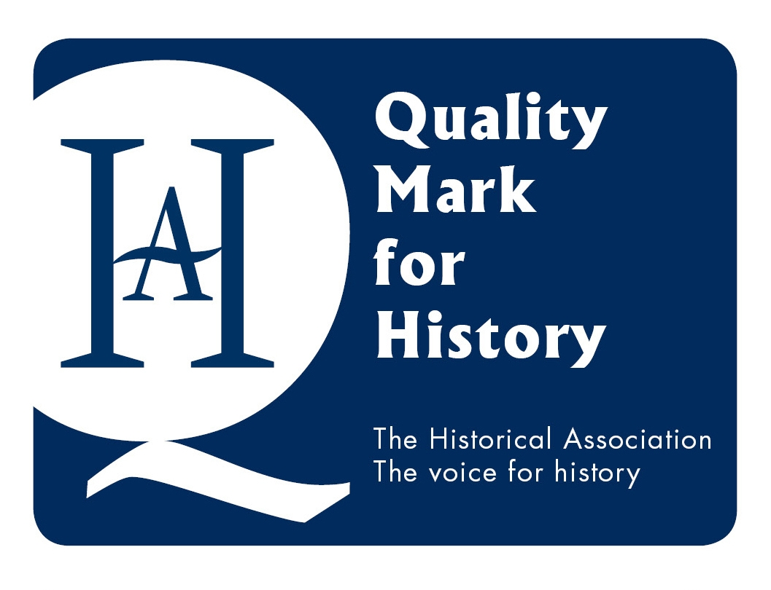 Historical Association Quality Mark Final Report
William Stockton Primary School  Ellesmere Port |  | Date: 23.5.23
William Stockton is a larger than average school with 361 children on roll. They are currently in the process of joining a Multi Academy Trust. In this school 49% of the children qualify for Pupil Premium, 18% SEND and 25% EAL, with 23 different languages spoken. There is a nursery on the premises but not all children in reception have attended this. The school population is not stable with numerous children arriving and leaving throughout the academic year.
This award is based on evidence from the portfolio, a visit to the school which included observation of two history lessons, a tour of the school, discussions with the Head Teacher, the Curriculum lead and Subject Leader, four members of teaching staff, four Year 1 pupils and two each of Year 3/4/5/6 pupils. Further evidence of floor books, pupils’ books, planning and Subject Leader documentation were also proved on the visit.

- Learning, Teaching and Achievement

The Year 1 pupils I met (Year 2 were busy with national tests) were enthusiastic about their history lessons. They could talk about their current and previous unit of work in history but were less confident to explain beyond this. The Key Stage 2 pupils were a contrast, they confidently discussed their current work, what a historian does, their favourite eras with clear justifications and suitable jobs for students good at history. These included archaeologists, working in a museum, doing research and one suggested a scientist as they have to prove their work and observe carefully too. These children were enthusiastic and used a range of impressive vocabulary confidently.

The EYFS floor books, children’s books and the two lessons I observed demonstrate that the children experience a wide range of carefully organised activities which progress in difficulty as they move through the school. The Year 1 class were learning about Victorian seaside holidays and there was a lot of discussion with the children making their own predictions about what the beach huts might have been used for. These included ‘rescue stations’, ‘toilets’ and ‘to protect from the waves’. The children were taken through a PowerPoint discussing a variety of aspects of a photograph and then given 4 more pictures to analyse in small groups. They were encouraged to speculate and write their ideas on a large worksheet with questions to prompt and guide them. All teachers consistently use the same format of CHAMPS across the school. C-concentrate the mind /H – home in on the facts / A activity or action / M – memorise / P prove it / S sit back and reflect on the learning.
The Year 6 pupils were exploring propaganda posters. The teacher recapped prior learning through questions on the causes of World War I before moving on to analyse and discuss one of the posters. The questioning brought out some interesting points, and the children made some interesting observations demonstrating a well-developed approach to analysis and criticality. The pupils then worked in smaller groups to consider 2 other posters and wrote their ideas on post-it notes. The school policy is that history lessons are active and do not focus on reading and writing but mainly on discussion, developing historical skills and vocabulary and both lessons demonstrated this approach well.
End Point assessments are completed by the children termly at the end of each unit. The teachers work in teams to ensure similar expectations across the year groups. These, as well as the teacher’s knowledge of the children, are used to record each child as Below, At, or Exceeding expectations. These statistics are then collected by the Subject Leader who monitors these results. Where there are anomalies, the Subject Leader has a discussion with the teacher to explore why this is and how it can be addressed. There is effective tracking based on valid criteria for progression used throughout the school. There is good progress relative to the children’s wide range of starting points. Groups of pupils, for example, girls and boys, SEND, minority heritage or gifted and talented children could be monitored more closely.

A good range of resources are used but this could be developed further. The school makes good use of suitable loan boxes, but many units do not have this support, in particular some of the schools’ own units e.g. History of Protest and Democracy. A range of suitable fiction and non-fiction texts are available in the library and in the classrooms.
The majority of marking was history based but most feedback is given verbally at the time in structured conversations with the children. Each piece of work in the books has a strip at the top of the page identifying the date, the aim of the lesson, historical skills developed in the lesson and in Key Stage 2 the concept threads. The children tick the historical skills they feel they have achieved and then either confidently, independently or with support is circled.
Timelines have been developed throughout the school with a clear focus and developing progression. Then/now is the focus of EYFS and then within/beyond living memory in Key Stage 1. A large overall timeline is displayed in the corridor and additional more focussed timelines are included on every history display. These show the current unit of work and also previous work so links can be made. Duration is marked on all timelines in Key Stage 1 and 2. Timelines showing the current unit of work are used in books.
The children identify what they already know, and any misconceptions are addressed and moved to a specific area of the display board so the children clearly understand this was a misunderstanding.

The evidence suggests that learning, teaching and achievement is at a Gold standard.
Targets:
1.23To develop the range of resources available for teachers, for example, replica artefacts, documents etc. for the units without access to loan boxes.
1.5 To begin to analyse the data to compare groups of children by gender, additional needs, minority heritage etc.
- Leadership

History has an excellent status at William Stockton as evidenced in a number of areas. The timetable allocation is an hour every week or two hours fortnightly depending on the age of the children and the unit being taught. The Head Teacher was knowledgeable and complimentary about history and how it has developed across the school. The Subject Leader has been teaching for nearly six years and works closely with the Curriculum Lead with further support from a member of staff who was a secondary history teacher previously. Management time allocation for the subject is 2 hours every four weeks for subject improvement and monitoring.

History is extremely well organised and managed by the Subject Leaders. Very good systems are applied consistently and efficiently. The criteria used throughout the school to evaluate performance demonstrate a good understanding of how this may be monitored, this includes: lesson observations, pupil voice, book and planning scrutiny, which take place regularly to carefully monitor the impact of the changes made. This is fed back to staff in staff meetings and on their ‘precision teach’ document which all staff have access to and is updated regularly. The Subject Leaders follow clearly defined structures with a clear role supporting the staff. This has included in-house CPD, support with planning, and suggestions for visits and visitors amongst others. Manageable and useful records are kept.
The staff I met were complimentary about the development of history across the school and the support they receive for teaching history. They were very enthusiastic about teaching history and felt much of this was due to the ownership they felt of the curriculum as they had all been involved in its development. The Subject Leaders disseminate anything which might be useful, HA Primary History articles, web sites, resources etc.
The children’s history books are made distinctive with a history themed picture on the front. On the inside cover is a ‘What Makes a Historian’ sheet identifying the key skills.
The Subject Leader has attended local Subject Leader forums but would benefit from developing further networking opportunities and should consider contributing an article to the Primary History Journal.
The evidence suggests that leadership is at a Gold standard.
Targets:
2.4 To develop links with other schools, including the local secondary schools, and Subject Leaders for support and to share expertise.
2.4 To write an article for the Primary History Journal to share good practice.
- Curriculum
This is the first full year of the current curriculum. It is well-designed, coherent and progressive across the school. An impressive bespoke long-term plan, it is designed to ensure a wide range of history is taught across the school. The EYFS curriculum incorporates history into the Understanding of the World with a strong emphasis on the development of language and vocabulary.
Local History is strong with good use made of the immediate area focusing on the school on and William Stockton who the school is named after. Ellesmere Port is the focus of the Year 3 Local History unit building on this. The Year 3/4 two-year cycle focuses on British history, Ancient Egypt and Monarchs. In Year 5/6 the two-year cycle broadens out exploring Maya, Ancient Greeks then exploring Crime and Punishment, the history of protest, democracy and World War I and II including a focus on a local hero. A focus on migration was considered but felt to be inappropriate as some of the children experienced trauma through migration prior to coming into the school.
Vocabulary is identified on teachers’ individual planning. This is also displayed in the corridors and addressed in every lesson. Conceptual threads have been identified and are built up through the curriculum. The concepts of Settlement and Invasion, Societal Change, Empires and History of our Locality have been developed and now need to be further embedded.
The curriculum needs to be evaluated further in terms of the range of diversity included. There are some interesting aspects, e.g. Harvey Milk in the Protest unit, but overall more examples of people from ethnic minorities and with disabilities would be welcomed.

The evidence suggests that curriculum is at a Gold standard.
Targets:
3.1 To embed and evaluate the curriculum as it moves through the two-year cycle for Key Stage 2 in particular.
3.1 To evaluate the diversity that is included across the units of history and make suitable adjustments and additions.
- Enrichment

History is explicitly considered but the school approach is generally more focused on each individual subject. Links are made to other subjects where appropriate, for example school value of the month, geography and maths especially in using the timelines. A specific fiction and non-fiction text could be identified to support the history but also to provide a context for developing an understanding of nonfiction features.
The school has ambassadors for science but not history so we discussed how these could be introduced and used to support younger children with vocabulary development, for example.
A range of visits, visitors and workshops take place through the year. There is an overall plan for this in the Subject Leader file to encourage each year group to include at least one of these each year related to the history. These include visits to Chester, Tatton Hall, Weaver Hall, London, a local church and mosque which was the first in the UK. A Maya archaeologist, Dr Diane Davies, was included in the Maya unit of work. Further online opportunities could be explored to minimise costs but still provide interesting and engaging experiences for the children.
A History Club for Year 5/6 children has been established with the pupils exploring aspects not covered in the curriculum. Recent content has included Titanic, World War II and medicines of the past. This is led by the children’s interests.
Parents and guardians are kept up to date through the Marvellous Me app and photographs of history activities are shared on the school web site. The History National Curriculum, whole school plan and progression document are available on the school web site.
The evidence suggests that enrichment is at a Silver standard.
Targets:
4.1 To identify a range of good quality fiction and non-fiction texts to support the units of History.
4.2 To introduce History Ambassadors.
Final Comments:
Many thanks to the Subject Leaders for their hard work. I thoroughly enjoyed my visit.
The Historical Association is extremely grateful to all involved in making the assessment process an enjoyable, manageable, and rewarding one. Many thanks.

Award made: Yes  Level: Gold | Date of Award:  23.5.23 |  | Renewal Date:  23.5.26

